**35 – Third Move to Arizona at 5054 E Fountain Circle – June 1986 to April 1987**

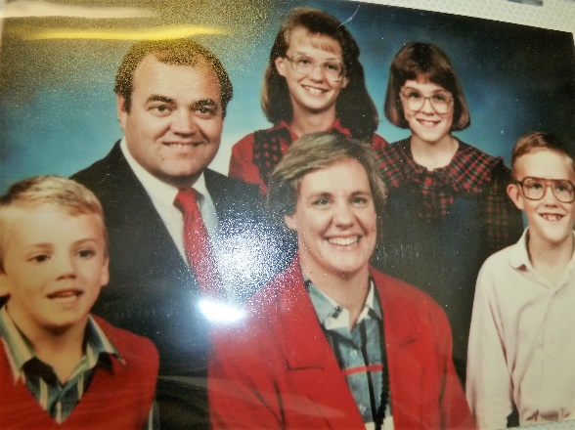Well, we decided to take Larry up on his offer, and we moved to Arizona. This was our third move to Mesa. The short, nine months we were there were hard, yet good. Good, because we lived in a lovely home in a nice neighborhood. We paid association dues and this included the use of the swimming pools, hot tubs, racket ball courts, volleyball pit and playground. It was a beautiful area where these were located. The boys and Ken loved to play racquetball, Shellie did too, and all of us loved the pools and hot tubs. We enjoyed the neighbors and our good ward. We had many opportunities to serve in the ward - Ken in the Bishopric again and me in Relief Society as a teacher and then as a counselor. We made lots of friends there too. One friend, **Lark**, was a neighbor. (Can’t remember her last name). She lived a block or two away. She was a cute lady and we had lots of good talks and enjoyed being together. We would go places together, and with our husbands sometimes too. They had a son about Jeff’s age and they became good friends too. A nice single mom lived about a block away and she had two sons. One was about Scotts age and the other about Jeff’s age. The four of them played together quite a lot. They were not members of the church, but very nice people. The mother made crafts in her spare time and around Easter, Jeff came home with the prettiest little Easter basket I had seen. It had lace and silk flowers on it and little plastic bunnies and Easter eggs in the basket. Jeff had seen it and wanted to buy it for me. He had some money saved so he bought it from her to give to me. I loved it. Jeff was so sweet to buy it for me. I still have it and enjoy putting it out as a decoration at Easter time.

We also enjoyed going to either the mountains with **Larry & Tammy** as they had a cabin there, or to the Lake with them as they had a boat and jet skis. **Mom & Dad came down to spend a month or so with us and it was great having them with us.** They both loved getting out of the cold winter and loved the warmth in Arizona. Dad would go on walks each morning and he really enjoyed doing that. Mom helped with the children, the meals, housework, etc. She was great! I enjoyed visiting and being with her and also with dad. They both were and are wonderful and we loved having them there.

The hard part of this move was because it didn’t work out with Ken and Larry being in business together. It did at first, but after a while Ron started questioning whether Larry was taking more out of the business than he should because he didn’t work much and he, Tammy and their family vacationed quite a bit and he always seemed to have plenty of money where Ron and Ken were working a lot and tight with money. When they first started out, they had their office in Larry’s nice new home and Tammy did the books. Larry, without talking to Ken or Ron, rented a nice office and hired a secretary. The business didn’t make that kind of money since a recession was on, so Ron and Ken were upset about that. Ron talked to Ken about his concerns and Ken told him he felt Larry was honest, but told Ron that, since they were all partners, he should just ask Larry if he could look at the books. He didn’t ask, he just came into the office early one day and was going over the books when Ken came in to get the house plans for the house he was building, before he started his day. The secretary wasn’t in when Ken came in, but was when he went out. We found out a few years later, in talking with Larry, that their secretary, Carine had told Larry that Ken and Ron were looking at the books. Larry felt they didn’t trust him and so he was very upset, called a meeting with them and told them they were on their own as of the first of the following month. When they asked why, he told them that since the business wasn’t bringing in enough money, the bank wasn’t going to keep backing them (something like that). Ken was devastated because that meant he and Ron would have to get someone to bond them and Ken didn’t have his own contractor’s license, he was working off Larry’s, so wouldn’t be able to get the bond company to bond him until he got his license. Larry hadn’t told the truth, he wanted them out since he was offended thinking that they didn’t trust him. Well, Ken kept trying to get work, but he was so discouraged that it turned to depression. That has been our hardest move, financially, and the feelings Ken and Larry had towards each other were not good as we moved back to Utah.

*Ken became so depressed because of the way Larry handled things that we had a terrible feeling in our home. The children didn’t like it. Mike & David even told me that maybe they should move out so it wouldn’t be so expensive. I told them that if they moved out, it would be much worse as I would be so sad and depressed too.* ***I got a call from our bank telling me that the IRS had come in and cleaned out our account because of money we owed them for back taxes while living in Idaho.*** *We had saved the money for taxes in Idaho and then had to use it when Ken was out of work for so long because of the farmers having those 3 bad years in succession. We had contacted the IRS and they had agreed to work with us and we would pay them so much every month - well, they didn’t work with us. I was really upset. Mom, dad and I were going to Dr. Swanstrom for a treatment, but while they were in getting their treatments, I went to a store and bought a newspaper so I could look in the Help adds to see about getting a job as I knew I needed to work now and try to get us out of this mess. I didn’t want to get a treatment as I didn’t have the money now. Dad insisted I get one and he would pay for it. There wasn’t anything much in the newspaper so I came home and prayed. I knew I couldn’t go to work for minimum wage, we needed more money than that.*

The thought came to me of Irven and how he was making good money working for **NFIB**. I called him to see if he thought I could do that. He said “Yes”, that I had the personality and the motivation to do it. He set up an appointment for me with his manager. I went in, had the interview, took the tests, passed with high scores and they hired me. It was hard memorizing all the issues and the information I needed, to give to the owners and presidents of companies and businesses. Mom fixed the meals, and did what she could and had me go out in the camp mobile, where it was quiet, and study. She was wonderful and a big help, so was dad. They insisted I use their small car, while they were there, as it got much better gas millage. I was really nervous the first day of work, but my trainer was very good and after watching him for about 3 times, he told me he would 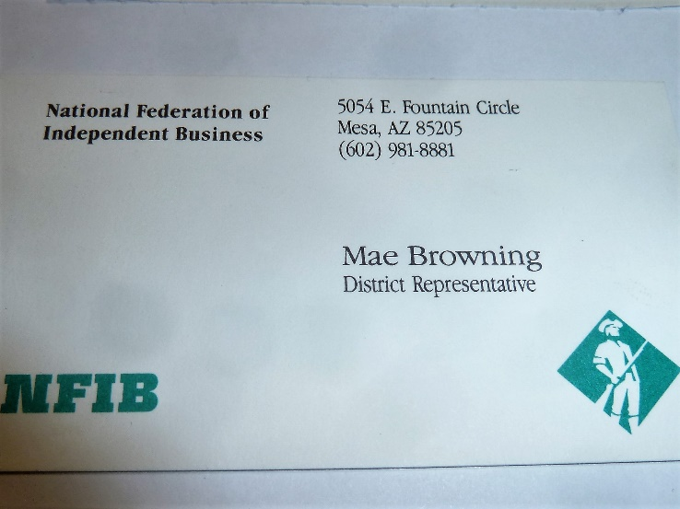wait in the car and for me to go in and try to make a sale. I had prayed hard and the Lord blessed me, as it went well and I made the sale. My manager was excited. I made several sales during the next two days so he left me on my own. Dave, my manager, called me his **“Super Star”.** It was hard as I had to go all over – Mesa, Tempe, Chandler, Phoenix, Globe, etc. At night I had to do lots of paperwork and get prepared for the next day.

**NFIB – working and what happened one day March 19, 1987**

I was really hoping to do good today. I didn’t get any sales yesterday, part of the day was spent with Dave Young, my manager. He is here meeting with all his people. He is a good boss, and a good person. He is my brother, Bryce’s friend, also a friend of Ken’s brother, Irven. Well – anyway, the morning wasn’t good. I drove all over – couldn’t find owners, couldn’t find addresses, roads were torn up, etc. I finally did new business, gave a couple of presentations, almost got one closed, then he changed his mind for the time. I went to sell another that we had already given the presentation to, but they want to wait for a month. I was pretty discouraged and upset because of the pressure. Dave had asked me to call him around noon so we could meet and he could give me some more cards he was getting from another representative. I finally got a hold of him and we met. He gave me lots of cards and supplies he had gotten from Norm Thompson, the Mesa representative who just went into another business because he needed more money to support his family. Dave invited me to go to lunch with him and even though I trust him (he loves his wife, is strong in the church, good friend to Bryce & Irven, etc.) and even though I hadn’t eaten lunch, I declined as I wanted to get to work and make some sales for the day. I drove to a shaded area, sorted the cards, drove off to Mesa to begin work again. I reached for my kit as I got out of the car and it wasn’t there. I looked all over the car and no kit. I started to panic because it had the checks in from the sales I had made this week. I got out and frantically looked through the boxes that Dave had given me, that were in the trunk. It was nowhere to be found. I was so upset and scared. I drove to a phone booth and called Dave. He was there, thank goodness. I asked him if I could have left my kit in his car. He ran out to check, but no, it wasn’t there. He asked if my kit had checks in it and I said “yes.” He could tell that I was really upset and worried, so he tried to console me by telling me how others had done similar things, tried to tell me funny things to get me to laugh, and told me not to take it personally – that things like that happen to lots of people and some things are lots worse. He was so understanding, I could hardly believe it. I told him at the first (after he told me it wasn’t in his car) that he should fire me. He said “I can’t, you’re one of my very best people.” He is always complimenting me and encouraging me. He’s a great boss – all his people think so. He told me to drive back to where we were parked – that maybe I had sat it on the trunk or the top of the car and forgot and driven off. That it might be there. I did. It was ½ mile away, but I drove fast. It wasn’t there. I went into businesses close by and asked if anyone had turned in a brown binder, but no one had. I wondered if I could have put it on the trunk when I sorted my cards, so I drove there. It wasn’t there. That was the same place (shopping center) where I had called Dave before, so I decided to go over and call him to tell him the bad news. He had told me that I could go back to the businesses who had given me checks and get them to stop payment on the checks and write me out new ones. I hated the thought of doing that, but I knew I would have to – but there was another problem. I couldn’t remember all the businesses that had given me checks – and I had no way of finding out as the receipt was with the person, and the membership card was with the checks in the kit. As I came up to the phone booth, it dawned on me (the Holy Ghost) that the last time I remember having my kit was when I gave a presentation to a jeweler in that shopping center so I might have laid it on top of the phone booth while I made the call four hours earlier. That maybe someone had turned it in to one of the stores, so I checked and no one had. I went back and called Dave. We discussed it some more and he again tried to console me. He told me that he had another copy of the membership list and Craig in Phoenix would make me up another kit and get it to me early the next morning. He said he wished he could help more, but he had so much to do. He had already helped so much and I sure appreciated it. He told me to cheer up and go sit in the car and think and let the Holy Ghost prompt me, that maybe I could still find it. If not, to go home and have a good evening and tomorrow would be a better day. As I went to leave the phone booth, I remembered that I better call home so the family wouldn’t worry. I noticed a man waiting to use the phone so I asked if I could make one more quick call. I told him something devastating had just happened. **He looked at me funny and said “You look familiar.” He had a business card in his hand. He said “You aren’t Mae Browning, are you?” I said “yes, do you have my brown book?” He did.** He had found it lying on top of the phone booth I had used earlier to call Dave. He had gone there to make a call. We walked to his big rig (he was a trucker) and he explained how he had found my book, and going through it, he saw the checks, etc., and knew the person who owned it might lose their job if they didn’t find it (most bosses would fire their people for this reason), so he found my business card and called our home. Scott answered, and this man left his name and number in California. But then he knew that if I called California, his brother-in-law (his partner wouldn’t know anything about it and wouldn’t be able to help me. He also knew that he couldn’t just leave my book at a store, etc., nearby as they might be dishonest and cash the checks. He knew he wouldn’t be back in Tempe for another week, and that I’d need it now. He waited around trying to figure out what to do. He looked on his map for my address, to take it there, but knew he couldn’t fit his rig down the roads in a housing division. He was to pick up a load at a certain time, but didn’t, as he felt he had to work something out for me. Four hours later, at the same phone booth, he was waiting to use the phone to call my home again to see if I was home by now and to see if I could meet him somewhere to get my book. **Wow!!! I knew the Lord had used him as an instrument in answering my prayers**. Here he, a good, honest, man (he didn’t look like one and a lot of truckers might not be) and he really went the extra mile to help me. I wanted to repay him somehow so gave him four dollars I had in my purse and asked him to give me his name and address and I would send him more money. I explained that we were having financial problems and that’s why I had gotten this job, but I didn’t tell him that to get out of paying him a reward or something, I was just upset and grateful and blurted it out. He said “no, I’m just glad I could help you.” I told him that I didn’t know if he was a Christian or not, but I was and I knew the Lord had used him – a good, honest man to answer my prayers. I also told him that if I couldn’t repay him for his extreme kindness, that I would help other people.

It really makes me realize that lately I haven’t taken time to help others or show love like I used to and should. I’ve felt so pressured lately that I haven’t. I will do better in the future

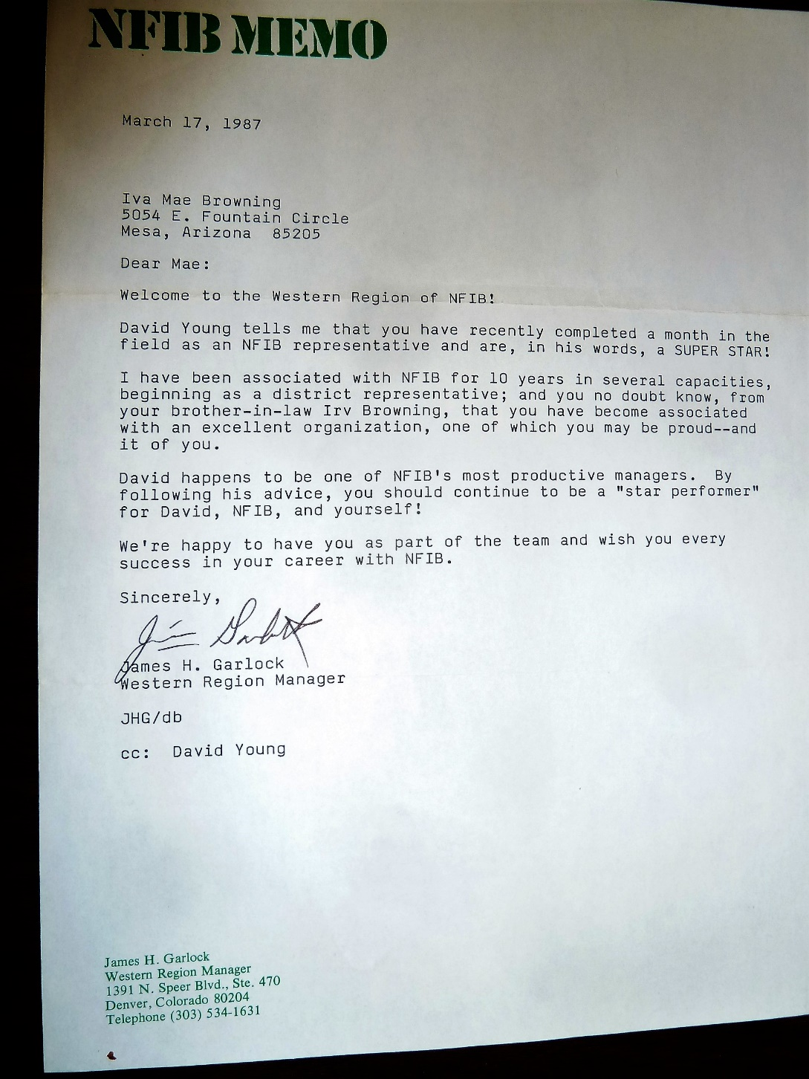

Finally, Mom & Dad decided they better go home. From that point on, the children had to help out as I didn’t have the time to do the laundry, clean the house, fix the meals, etc. Shellie would start supper, then have to go to work, so Scott had to finish it as Mike was working also and David was in school and worked part time at the same place as Shellie & Mike. *Shellie had found the job. It was at an Assisted Living Center so they had a nice lunch room where these seniors were served 3 nice meals a day. Shellie was the waitress. They needed someone to wash dishes so she had Mike come apply for the job. He was hired and the managers really liked Shellie & Mike as they were hard workers and dependable. Later, when the cook resigned, they offered Mike that job and asked if they had another brother or sister who would like to work part-time doing dishes. Well, David got the job. When they saw how dependable and hardworking David was also, they asked if they had any other family members they could hire*. This was quite a compliment. When we moved, the managers were really sad and they couldn’t say enough good about our special children. We are so proud of them.

**UPDATE ON CHILDREN**

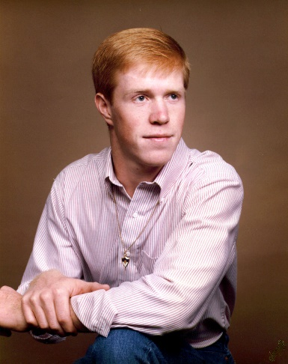**Mike** - It was the summer before Mike’s senior year that we moved down to Arizona. He wanted to graduate from Firth High, not a new school, so Mike Mecham’s parents talked to us about letting Mike stay with them for the school year and graduate with their son, Mike. They were such good people and strong in the church that we felt Mike would be fine staying with them, however, Mike was steady dating with Lisa and even though I felt I could trust Mike, I didn’t trust the devil and worried about this. I talked to the seminary principal and he felt we shouldn’t do it. He said Mike and Lisa were both good kids, but if it were him, he wouldn’t do it. I told Ken this, but he said we had to trust Mike. He talked to Mike and told him that if anything happened, that he (Ken) would never hear the last of it from me. Mike promised him that everything would be ok, and it was because shortly after Mike started school, he and Lisa broke up and he dated Mishael and others. Mike had moved down with us for the summer and then went back in the fall. **Bo** moved down with us too and then left to go back to Spain from there. One incident happened with Bo when we were moving things into the home. I had brought all my beautiful plants down and they were in one vehicle. Ken had asked Bo to bring them into the home. He got side tracked and forgot about them. We were all busy and when we realized they were still out in the “hot” car as it was during the summer and with the windows all up, all but one of the plants died. I was sick about it as I loved my plants, but I didn’t say much to Bo as he felt really bad as it was. Bo enjoyed part of the summer with us until he had to fly back home. The morning that we took him to the airport was quite a traumatic time too. He left his plane ticket on top on the piano when we left the house. We had plenty of time to make the flight, but not much extra. On the way I asked him something about his ticket and he gasped. I asked him what was the matter and he said he forgot to pick them up from the piano. He put them there as he thought he would see them as he left the house. We had to turn around and go get them. It was about 4 am in the morning so there wasn’t much traffic and Ken ran red lights – just slowing down to see if anyone was coming from the other roads and if there were any policemen around. We did make it in time, thank goodness. We enjoyed that year with Bo, he was a special young man.

**David -** This move was hard on David for several reasons. One reason was because Mike went back to Firth to go to school his senior year and Mike & David had been so close. But David became close to Scott & Jeff and was cute with them. Another reason was David went to the biggest high school in Mesa. That was tough coming from such a small high school in Firth where he knew everyone and was popular. Here at this high school the kids came from wealthy homes and so most of them had their own cars, etc. David took Spanish and his Spanish teacher was from Spain and was a great teacher. David liked this class more than the others. Mike finished up his credits about half way through the year and so came home to Mesa to be with us and find work.

**Scott -** This move was hard on Scott too. He was in a big Jr High by himself. He didn’t like the school. He did make friends with a couple of neighbor boys who were brothers and they all played together. Their mother was a single mom, but very nice. They were not members of the church, but good people. Scott’s scout leader was very good, but strict. He made Scott his Sr. Patrol Leader. Scott was good, but it was hard for him with the leader being so strict. Scott took band and played the trumpet. His teacher said he was very good and that he would give him private lessons if we consented. I was going to do this, but we moved too soon. I don’t remember if he had any private lessons or not.

**Jeff -** This move wasn’t as hard on Jeff, at least I don’t think so as he was younger. He went to the elementary school and had a good teacher. He made friends with a cute boy in our neighborhood and ward. His mother and I were friends. Her name was Lark, but I can’t remember the boy’s name. Jeff was a good boy and he loved playing with Naunoo and Penny.

**Shellie** had gone down with Ken so she could find work before going back to BYU. They stayed with Larry & Tammy, and Tammy was very good with her. At this time, Larry & Tammy were going to some classes “Love” classes that were supposed to teach you more love so you could have better relationships with your spouse and others. It wasn’t a good thing. They tried to talk Ken and Shellie into going, but they didn’t feel good about it, so didn’t go. The classes caused problems for Larry & Tammy and so they struggled with their marriage. They had made Tammy one of their assistant leaders. At one time, the main person called Tammy, while their family was having Family Home Evening and discussing the problems they were having since going to and being involved with these classes and people. He said “What is going on at your house?” It scared Tammy as she felt this was coming from the devil. Tammy said that the man would never look into her eyes, so she forced him to and she said it was like looking into the eyes of the devil. It scared her so bad that she quit and they left that atmosphere. I’m not sure what else happened there.

Shellie worked at McDonalds first, and then waitressed at an Assisted Living Center. Mike and David ended up working there too. Two weeks before we were to move back to Utah, Shellie met Roy at a single adult dance. He had just returned from his mission and was staying with his sister, Carolyn, and her family who lived in Mesa. She introduced herself to him and introduced him to others. They started dancing and he asked to take her home. She had come with a friend, so the friend was ok with it and drove home alone. From that time on, Shellie and Roy were together as much as possible. Even while we were packing to move, Shellie was water skiing with Roy and his family. Mike & David didn’t think it was fair that she didn’t have to be home helping us pack. It probably wasn’t fair, but life isn’t fair.

Ken hated the idea of me working, he had never wanted me to work outside the home, but I had no choice at that time - so this contributed to **his depression**. Other things added to his depression - Ken had been called to be a counselor in the Bishopric in our ward and Larry had had a fit because he told Ken he needed to spend all his time getting the business to work, and shouldn’t have accepted the call to be in the Bishopric. Ken told him that he had covenanted to give his time, talents, etc., to the Lord and he would do it when he was asked. Larry was upset about this and even talked to me about it. I agreed with Ken and I told Larry so. Ken finally did talk to the Bishop about it and was released. That was really hard for Ken as he didn’t feel right about it. Another problem was it was dog eat dog in the construction business in Arizona. Guys were coming from all other states because the word was out that building was doing great in Arizona. Many didn’t have a license or insurance and would just work out of their trucks - so would underbid Ken and get the jobs. Even when he did the jobs, many wouldn’t pay him or their checks would bounce. It was really hard, so I could understand why Ken was so depressed - but it was really hard on me with him that way. I fasted and prayed, I talked to the Bishop, our home teachers, and finally **Scott** came home from school really excited about a lady who had come and gave a presentation to them on positive thinking. I got her name and address from the school and found out she lived in Mesa. I called her and also found out that she did counseling sessions. She was a member of the church, her husband had cancer and she had turned to the Lord for help and she felt he had really blessed her. She wrote two books and had tapes made. I purchased them and had Ken come to counseling sessions. He went, but didn’t get much out of them because of his attitude. I went with him and thought they were great. I have used the books and tapes several times to help other people - I have loaned them out.

**I finally was beside myself and told Ken he had to snap out of it because I couldn’t take much more of it. He asked me if I would be willing to move in with his mother in Utah**. His mother was a widow and had a fairly large home because it had a finished basement. It had five bedrooms. Ken had suggested that before, but I would never agree to it because I didn’t feel I could live with his mother. She was a good person, but completely opposite from my mother and how I had been raised. She wasn’t loving and caring to our children like my mother was, she did love her children, in fact, she thinks they are about perfect. That’s how most mothers are I guess, but I’m sure she thinks she loves her grandchildren, but she doesn’t show it. She is critical of them and expects way too much from them. She doesn’t act how I feel a grandmother should act to her grandchildren. She is an emulate housekeeper, and so having a clean house was what was most important to her. She told me that I should clean above my doors and the mopboards every time I mop the floor and that I should mop the floor 2 or 3 times a week. Well, I wipe up the floor when something is spilled or when it needs it, and I mop it on Saturdays, but I don’t clean the mopboards and above the doors that often. I do it when I see it needs it and when I have the time. Having a immaculately clean house is not my mom’s priority, her family and other people are. Mom isn’t a good housekeeper. She liked a clean house so I cleaned it for her a lot, but she couldn’t seem to keep it clean. She would hardly ever put things away after she had used them. I have tried to have a balance. I like a clean house too, but it isn’t my number one priority. My family, the church, and friends come above it - at least most of the time.

I would rather have wanted to move in with my Mom & Dad, but in talking to Mom, she was excited about having us do that, but when I talked about her getting rid of some of her things to make room for ours, she couldn’t do it. I was sure that would be the case as Mom is a horter, and she can’t get rid of anything.

**I was so desperate at this time that after Ken asked if I would at least fast and pray about it, I did. I received a good feeling that we should do it and so I trusted in the Lord, we called his mom, she agreed and we moved up**. It was hard to leave my beautiful home, area and friends, however. I had decorated the house, had my friend, Molly, help me make drapes for the windows in the family room, dining room and large living room. Ken made boxes and we covered them with the same material and trimmed them with the gold cord we used as tiebacks for the drapes. He fastened them to the walls above the windows. They looked beautiful. I was able to buy this material in bulk at a factory outlet store. It looked like linen. They looked beautiful. We bought sheers to put behind them. I made curtains, drapes, bedspreads, etc. for our bedroom and the other bedrooms. When the realtors took perspective buyers through our home, they told them that we had “custom drapes”. I guess we did. The realtors said these were a big selling point. It was a beautiful home, the nicest I have had and all our homes have been nice. Ken asked Larry if he wanted the house as he had helped us with the down payment. He said no, so we talked to a realtor in our ward that listed it and sold it. We made enough to pay for the big moving truck and the gas to move us up. It seems like we even borrowed some from the children. It was a caravan moving up. We had mom & dad’s camp mobile, the big truck, and 2 cars. Ken drove the big truck, Mike, David & Shellie each drove a vehicle.

We had two cats here in this home in Mesa, and we couldn’t take them with us to Ken’s mother’s house so Ken had Shellie take them to the pound when we moved. They were so upset and one got under the car seat and Shellie had to drag it out. It was really an ordeal for Shellie.

**1986 Christmas letter**

This past June, we made another move. We had lived in Firth, Idaho for two years and loved it there (except for the long, cold winters.) We lived near the Snake River, and it was so beautiful with all the trees, bushes, and freshly plowed fields in the spring or late fall, or potatoes, hay, or grain growing in them during the spring and summer months. We had wonderful neighbors that we grew to love – so it was very heard to leave them. Also, a great ward where we had lots of opportunities to grow and serve. Our children sure hated to leave their good friends, and the great life in the country. They went to small schools so had opportunities in sports and all other areas which they desired. During the summer and after school, the boys could get part-time jobs working for the farmers. They liked to ride their motorcycles, or go fishing and hunting during their free time, while Shellie would be dating, doing things with her friends, or just curling up with a good book.

Ken went from farming (managing the Grantsville Stake Welfare Farm) in Grantsville, Utah to back into the building profession when we moved to Idaho. He also sold insurance part time. The harvest in 1985 wasn’t good for the farmers, and since the economy revolves around the farming, the area became depressed. Actually, this was their 3rd bad year so many were really struggling or going under. People couldn’t afford to build new homes or do remodeling, so Ken looked for work elsewhere. Our good friends, Larry & Tammy Braithwaite, whom Ken has been in business with before, live in Mesa, Arizona. They had visited us a few months earlier, and told us that building was really booming in Arizona, and Larry was doing really well as a contractor. Ken left in February to stay with the Braithwaite’s and work down there until school was out. During this time Larry offered Ken to go into partnership with him. Not knowing what else to do, and since it was such a good offer, we moved down in June.

The summer was hot (as you can imagine here in Arizona), but our homes and all the businesses are air-conditioned, and everyone swims a lot. We bought a nice home, and live in a good ward and neighborhood, so we’re happy here too. We had a good summer. Larry & Tammy have a boat, jet skis’ and a cabin in the mountains so they took us with them where our families could renew their friendships and have a good time.

People have been coming here from all over the country to find work, so there is a lot of competition for the jobs. So far, the work is still coming in and they have kept fairly busy. We hope and pray it will continue to do so.

The growth here in Mesa is almost unbelievable. Our ward had almost a thousand members by the time we divided three weeks ago. Ken is now in the Bishopric of our new ward, and I am in the Relief Society Presidency. David isn’t too happy about the division because he is now the only active priest in our ward. We have a fairly young ward so we have a big primary and small M.I.A. It seems to be a great ward; however, the members are excited to be divided and able to hold positions. In our old ward, there were too many people and not enough positions.

**Mike is staying with some good friends of ours in Firth as he wanted to remain there for his senior year of high school, and be able to play football**. He didn’t feel he’d have a chance here at Mountain View High with the student body of 3,000 compared to 300 in Firth. Mountain View is a great high school, though, and **David** has adjusted and really likes it.  **Scott** goes to Poston Jr. High, and **Jeff** to a new elementary school just blocks from our home. He rides his bike and enjoys the school. He’s in the third grade. **Shellie** had a tough time adjusting to BYU last year. It was overwhelming coming from such small high schools as Grantsville and Firth, but this 2nd year, she has adjusted and loves everything about it – well, maybe not all the homework. She had several boyfriends and opportunities for marriage, but she has a goal of going to Israel with BYU on the Travel Abroad Program so if she earns enough money, she plans to go with them next year. We’re excited for her and hope she can. Her major in college is Elementary Education.

Our oldest daughter, **Sandi**, her husband, Dave, and their two little daughters, JaNae and Chelci, still live in Grantsville and we miss not being able to see and be with them often. We went up to Utah for Thanksgiving so we could have our family all together and be with our parents and loved ones, and we had a wonderful time.

Ken’s Mom, Sandi and the little girls were here for a visit during the summer, also my brother Terry and his family from Alaska came. My parents came down during October and will come again after Christmas to stay awhile and get out of the cold in Utah. We are looking forward to them coming.

Ken and I were talking the other day about our many moves and the experiences we’ve had and the great people we’ve met, so even though our life thus far, hasn’t been too profitable financially, we have enjoyed a good life and we decided we wouldn’t trade it if we had the chance to do it over again. (I read this to Ken, and he said “Well, maybe I would change some of it.) Our life has been exciting, (most of the time) and we’ve had lots of wonderful opportunities and experiences. Ken and I love each other, our special children, the gospel, our Heavenly Father, and his son Jesus Christ, our wonderful parents and brothers and sisters, and all our friends.